Read



Write

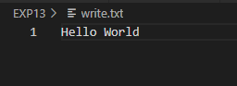

Zip

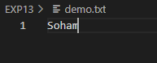



Pipe

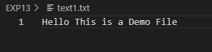



After piping

